**Hospital Appointment**

**System**

Albert Biju

Roll-No:7

BTECH

10/7/2024

Introduction

Brief Overview:

This mini-project is designed to book appointments for users with the doctors they need. The interface allows the user to create a file with their basic details, such as name, address, and age. Each patient file is accessed with the help of a Patient Identity Number (PIN). The user can either book an appointment and check their appointment or make a follow-up with their previous doctor.

Problem Statement:

Implement a system for patients to book appointments with doctors, manage scheduling, and display availability.

Objective:

This mini-project is designed to streamline the process of booking appointments with doctors in a hospital setting.This project aims to provide an efficient, user-friendly interface for both patients and hospital staff to manage appointments.

System Requirements

Hardware requirements:

RAM Processor: Any modern processor (x86 or ARM) will suffice.

RAM: The amount of RAM required depends on the size and complexity of your C program. For simple programs, a few megabytes will be enough.

Storage: You'll need enough storage space to store your C code files, the compiled executable file, and any data files used by your program.

Software requirements:

Text Editor: To write your C code.

C Compiler: To translate your human-readable C code into machine-executable instructions.

Command Prompt/Terminal: To compile and execute your program.

Design and Development

Description of program logic:

The programme consists of the main function and five user-defined functions.The main function provides the choices of tasks that the programme can perform. Mainly, book an appointment, check an appointment, and book a follow-up.

If the choice is to book an appointment, then it will ask if you already have an existing file in the hospital. If yes, then you can enter the patient identity number and access the patient file. If you don’t have an existing file in the hospital, you can create a new one by entering your name, age, and address.

After accessing the file, you will be provided with the names of the names of the doctors present in the hospital, and you can choose which doctor you want to book an appointment with. You can enter the date you want to book an appointment on, and it will return if the doctor is available or not. If the doctor is available, then you can confirm the booking, or else you can enter another date to check if they are not available.

If the choice chosen is to check an appointment, then you are asked to enter your PIN and check your appointments.

If the choice is to follow up, then you can enter the PIN and book a follow-up with the doctor you want on the date they are available.

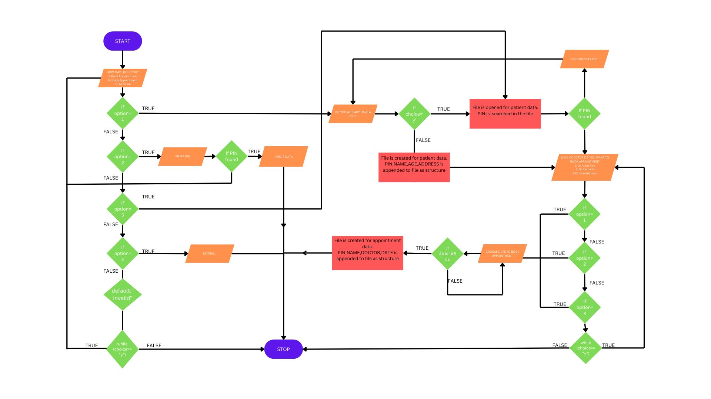

Test Cases

1. Booking appointment (you have a existing file)

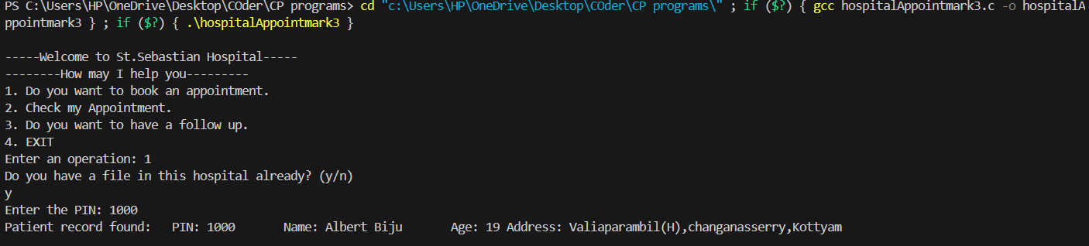

1.2-Booking appointment(Don’t have an existing file)

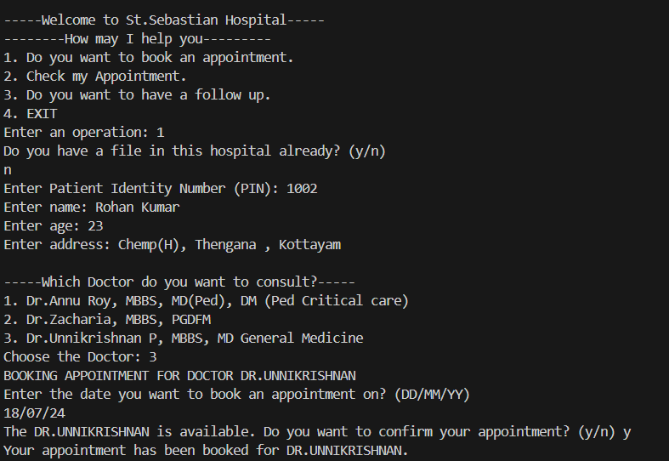

2-Choosing the doctor and making the appointment if they are available

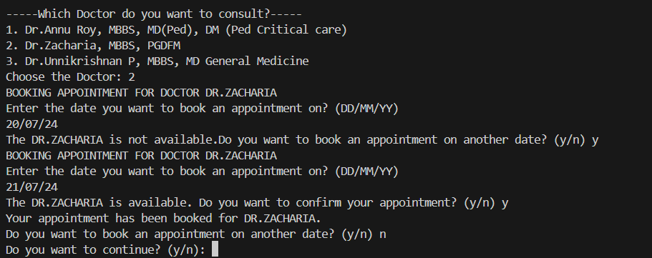

3-Checking for appointment

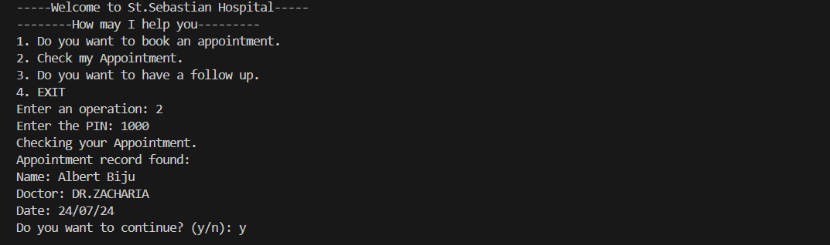

4-Make a follow up

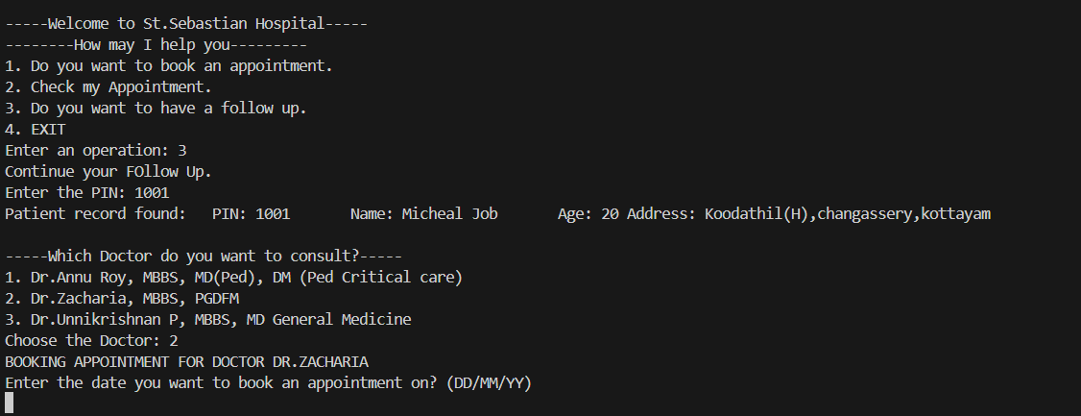

5-Invalid options

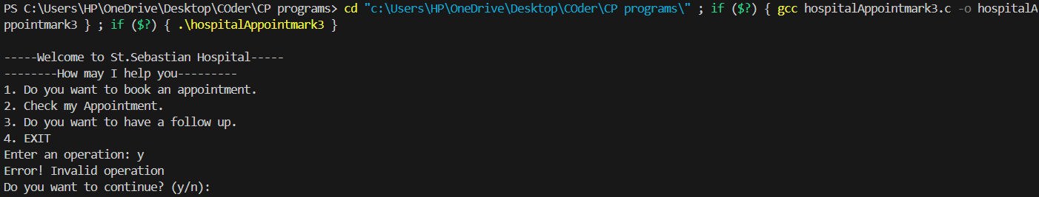

Summary

These kind of systems allow the users to easily book, check, and manage their medical appointments through a user-friendly interface, reducing the need for time-consuming phone calls or in-person visits. The program provides up-to-date information on doctor availability, allowing patients to choose the most convenient times for their appointments and making the scheduling process more flexible.This Hospital Appointment System stands out by prioritizing both patient convenience and healthcare provider efficiency, ultimately leading to improved patient satisfaction and better healthcare outcomes.

Future Enhancements

In terms of basic functionality and necessities the program is apt to perform efficiently but there are room for improvement in the future. Currently all patient details are saved in a single file due to less sample size and few number of patient information initialized. Same with the appointment details, currently the doctor and date of all patients are stored with the PIN as reference into a single file . In the future it would be a better idea to create separate file for patients , with more patient information and record the appointments to there personal files. Another method could be Linking the interface with a database rather than separate files would be a more plausible and dynamic solution.

References

* <https://www.geeksforgeeks.org/generating-random-number-range-c/>
* <https://www.geeksforgeeks.org/read-write-structure-from-to-a-file-in-c/>
* <https://www.geeksforgeeks.org/strcspn-in-c/>

Appendices

#include <stdio.h>

#include <stdlib.h>

#include <string.h>

#include <math.h>

#include <time.h>

struct Patients {

int PIN;

char NAME[40];

int AGE;

char ADDRESS[100];

};

struct Appointment {

int PIN;

char NAME[40];

char DOCTOR[100];

char DATE[10];

};

void readPIN(int);

void openAcc(struct Patients *p);

void appointmentDoctor(int, char[100]);

int chooseDoctor(int);

void checkAppointment(int pin);

void readPIN(int pin) {

FILE *fp = fopen("data.dat", "rb");

if (fp == NULL) {

perror("Failed to open file");

return;

}

struct Patients p;

int found = 0;

while (fread(&p, sizeof(struct Patients), 1, fp) == 1) {

if (p.PIN == pin) {

printf("Patient record found:\t");

printf("PIN: %d\t", p.PIN);

printf("Name: %s\t", p.NAME);

printf("Age: %d\t", p.AGE);

printf("Address: %s\n", p.ADDRESS);

found = 1;

chooseDoctor(pin);

break;

}

}

if (!found) {

printf("Patient with PIN %d not found.\n", pin);

}

fclose(fp);

}

void openAcc(struct Patients *p) {

// Read from Keyboard

printf("Enter Patient Identity Number (PIN): ");

scanf("%d", &p->PIN);

getchar();

printf("Enter name: ");

fgets(p->NAME, sizeof(p->NAME), stdin);

p->NAME[strcspn(p->NAME, "\n")] = '\0';

printf("Enter age: ");

scanf("%d", &p->AGE);

getchar();

printf("Enter address: ");

fgets(p->ADDRESS, sizeof(p->ADDRESS), stdin);

p->ADDRESS[strcspn(p->ADDRESS, "\n")] = '\0';

FILE *fp = fopen("data.dat", "ab");

if (fp == NULL) {

perror("Failed to open file");

return;

}

fwrite(p, sizeof(struct Patients), 1, fp);

fclose(fp);

chooseDoctor(p->PIN);

}

void appointmentDoctor(int pin, char doctor[100]) {

char date[10], choice,option;

struct Appointment a;

struct Patients p;

FILE *fp1 = fopen("data.dat", "rb");

if (fp1 == NULL) {

perror("Failed to open file");

return;

}

do {

int num = (rand() % 10) + 1;

printf("BOOKING APPOINTMENT FOR DOCTOR %s\n",doctor);

printf("Enter the date you want to book an appointment on? (DD/MM/YY)\n");

fgets(date, sizeof(date), stdin);

date[strcspn(date, "\n")] = '\0';

if (num < 8) {

printf("The %s is not available.",doctor);

} else {

printf("The %s is available. Do you want to confirm your appointment? (y/n) ",doctor);

scanf(" %c", &option);

getchar();

if (option == 'y' || option == 'Y') {

a.PIN = pin;

while (fread(&p, sizeof(struct Patients), 1, fp1) == 1) {

if (p.PIN == pin) {

strcpy(a.NAME, p.NAME);

break;

}

}

strcpy(a.DOCTOR, doctor);

strcpy(a.DATE, date);

FILE *fp2 = fopen("appointment.dat", "ab");

if (fp2 == NULL) {

perror("Failed to open file");

exit(1);

}

fwrite(&a, sizeof(struct Appointment), 1, fp2);

fclose(fp2);

printf("Your appointment has been booked for %s.\n",doctor);

}

}

printf("Do you want to book an appointment on another date? (y/n) ");

scanf(" %c", &choice);

getchar();

} while (choice == 'y' || choice == 'Y');

fclose(fp1);

}

int chooseDoctor(int pin) {

srand(time(0));

int operation;

char choice;

do{

printf("\n-----Which Doctor do you want to consult?-----\n");

printf("1. Dr.Annu Roy, MBBS, MD(Ped), DM (Ped Critical care)\n");

printf("2. Dr.Zacharia, MBBS, PGDFM\n");

printf("3. Dr.Unnikrishnan P, MBBS, MD General Medicine\n");

printf("Choose the Doctor: ");

scanf(" %d", &operation);

getchar();

switch (operation) {

case 1:

appointmentDoctor(pin, "DR.ANNU ROY");

break;

case 2:

appointmentDoctor(pin, "DR.ZACHARIA");

break;

case 3:

appointmentDoctor(pin, "DR.UNNIKRISHNAN");

break;

default:

printf("Error! Invalid operation\n");

break;

printf("Do you want to book another appointment? (y/n) ");

scanf(" %c", &choice);

getchar();

}

}while (choice == 'y' || choice == 'Y');

return 0;

}

void checkAppointment(int pin) {

printf("Checking your Appointment.\n");

struct Appointment a;

int found = 0;

FILE *fp = fopen("appointment.dat", "rb");

if (fp == NULL) {

perror("Failed to open file");

return;

}

while (fread(&a, sizeof(struct Appointment), 1, fp) == 1) {

if (a.PIN == pin) {

printf("Appointment record found:\n");

printf("Name: %s\t", a.NAME);

printf("Doctor: %s\t", a.DOCTOR);

printf("Date: %s\n", a.DATE);

found = 1;

break;;

}

}

if (!found) {

printf("Appointment with PIN %d not found.\n", pin);

}

fclose(fp);

}

int main() {

int operation, PIN;

char choice;

struct Patients patients;

do {

printf("\n-----Welcome to St.Sebastian Hospital-----\n");

printf("--------How may I help you---------\n");

printf("1. Do you want to book an appointment.\n");

printf("2. Check my Appointment.\n");

printf("3. Do you want to have a follow up.\n");

printf("4. EXIT\n");

printf("Enter an operation: ");

scanf(" %d", &operation);

switch (operation) {

case 1:

printf("Do you have a file in this hospital already? (y/n)\n");

scanf(" %c", &choice);

getchar();

if (choice == 'y' || choice == 'Y') {

printf("Enter the PIN: ");

scanf("%d", &PIN);

getchar();

readPIN(PIN);

} else if (choice == 'n' || choice == 'N') {

openAcc(&patients);

}

break;

case 2:

printf("Enter the PIN: ");

scanf("%d", &PIN);

getchar();

checkAppointment(PIN);

break;

case 3:

printf("Continue your FOllow Up.\n");

printf("Enter the PIN: ");

scanf("%d", &PIN);

getchar();

readPIN(PIN);

break;

case 4:

printf("EXITING....\n");

break;

default:

printf("Error! Invalid operation\n");

break;

}

printf("Do you want to continue? (y/n): ");

scanf(" %c", &choice);

getchar();

} while (choice == 'y' || choice == 'Y');

return 0;

}